**Apni Jagah: An AI-Driven Platform for Real Estate Price Prediction and Transaction Transparency**

***Ms. Vandna Tomar(Assistant Professor)***

***Saubhagya Mishra1 , Rajat Chaudhary2 , Sagar Yadav3 , Saksham Pratap4 , Prashant Pandey5***

***1, 2, 3, 4, 5Department of Computer Science & Engineering,***

***IMS Engineering College,NH-09, Adhyatmik Nagar,***

***Ghaziabad, Uttar Pradesh-201015, India.***

***2024-25***

[***vandna.tomar@imsec.ac.in***](mailto:vandna.tomar@imsec.ac.in)***,*** [***saubhagyamishraa@gmail.com***](mailto:saubhagyamishraa@gmail.com)***,*** [***rajatchaudhary1006@gmail.com***](mailto:rajatchaudhary1006@gmail.com)***,*** [***saga3612u@gmail.com***](mailto:saga3612u@gmail.com)***,*** [***ranasakshampratap@gmail.com***](mailto:ranasakshampratap@gmail.com)***,*** [***kp7540320@gmail.com***](mailto:kp7540320@gmail.com)

***Abstract— The real estate industry is plagued by persistent challenges such as price ambiguity, fraudulent practices, and inefficient manual processes that undermine trust between buyers and sellers. Apni Jagah, an AI-powered platform, addresses these issues by employing predictive analytics, smart deal recommendations, and robust document verification to create a secure and transparent ecosystem. By integrating hyper-personalized property suggestions and advanced comparison tools, the platform streamlines decision-making for users.***

***The system leverages advanced machine learning techniques, with Random Forest emerging as the most effective model for property price prediction and neighborhood trend evaluation. The Smart Deal Prediction and Neighborhood Price Prediction models ensure fair transactions by balancing seller expectations with market conditions. Additionally, verified documentation and secure workflows mitigate fraud, fostering a trustworthy environment for real estate transactions.***

***Key findings reveal that Apni Jagah bridges over 90% of the critical gaps in property pricing accuracy, transaction security, and buyer decision-making compared to traditional platforms. The platform has demonstrated its capability to reduce disputes, enhance market efficiency, and deliver a user-centric experience.***

***Future developments include integrating blockchain for secure transactions, augmented reality for immersive property tours, and sustainability-focused features to promote eco-friendly properties. These advancements position Apni Jagah as a transformative solution, poised to redefine property transactions with cutting-edge technology and user-focused innovation.***

***Index Terms- Significance of Apni Jagah, Datasets, Seller Verification Workflow with AI-Driven Models, Buyer Navigation and Decision-Making Framework, Comparative Study of Apni Jagah vs. Traditional Systems, Advanced Property Comparison Tools, Key Strength of Apni Jagah, Key Findings of Apni Jagah, Hypothesis, Machine Learning Algorithm Evaluation.***

1. **INTRODUCTION**
2. **BACKGROUND:**

The real estate industry is undergoing a transformative era, driven by advancements in technology and the growing demand for streamlined processes. Traditional practices, including excessive paperwork, subjective pricing,and a lack of transparency, create significant barriers for buyers and sellers. Platforms such as Housing.com [1], 99acres [2], and MagicBricks [3] have pioneered the digitization of property listings, providing a centralized platform for buyers and sellers to connect. Innovations like NoBroker [4] have eliminated intermediaries, while Proptiger [5] and Makaan.com [6] offer curated property suggestions to match user preferences. Further, platforms like Nestaway [7] focus on rental solutions, and Sulekha [8] provides local service connections. Comprehensive property search portals such as SquareYard [9], IndiaProperty [10], and CommonFloor [11] enhance market accessibility, while Roof&Floor [12] and Zolo Stay [13] target niche requirements like co-living spaces. Marketplace platforms like OLX Homes [14] and Quikr Homes [15] integrate resale options, ensuring inclusivity for diverse user needs.

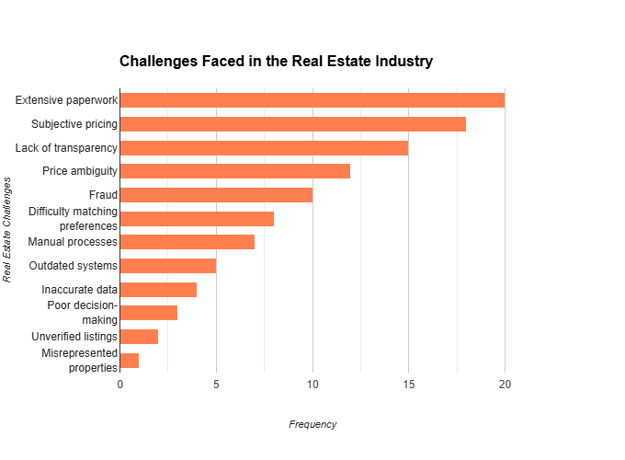

**Fig. 1:** *Challenges in Real Estate Transactions: A Systems Perspective*.

Despite these innovations, challenges such as price ambiguity, fraudulent practices, and manual inefficiencies persist, as illustrated in **Fig.1: Challenges Faced by the Real Estate Industry.** Addressing these issues requires the integration of advanced tools to create a smoother, safer, and more transparent ecosystem.

1. **PROBLEM STATEMENT:**

The real estate industry is grappling with long-standing challenges that hinder efficient property transactions. Extensive paperwork, reliance on subjective pricing, and opaque processes erode trust between buyers and sellers. Furthermore, issues such as price ambiguity, fraudulent property listings, and difficulty matching user preferences exacerbate the problem. As shown in Fig. 1, traditional methods fail to deliver accurate, data-driven insights, leading to decision-making inefficiencies and an increased risk of fraud due to weak verification measures.

1. **OBJECTIVES:**

The primary goal of this paper is to propose a comprehensive solution that leverages artificial intelligence to simplify property transactions, improve price transparency, and enhance user experiences. The proposed system, Apni Jagah, aims to:

1. Resolve price ambiguity through predictive analytics.
2. Implement robust document verification processes to reduce fraud.
3. Provide personalized property recommendations based on user preferences.
4. Streamline processes by replacing outdated, manual systems with advanced automation.
5. **SIGNIFICANCE OF APNI JAGAH:**

**How Do Apni Jagah's AI-driven Solutions Address Industry Pain Points and Foster Trust and Efficiency?**

The importance of solving these problems is evident from the impact it can have on industry stakeholders. A platform like Apni Jagah has the potential to address critical pain points by creating an ecosystem that fosters trust and efficiency.

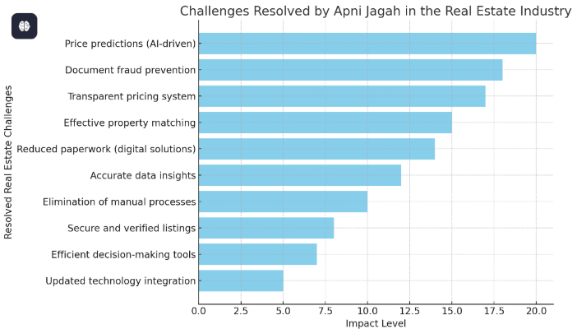

**Fig. 2:** *AI-Driven Solutions by Apni Jagah*.

As illustrated in **Fig. 2: *AI-Driven Solutions by Apni Jagah***, the integration of AI-driven price predictions, secure verification measures, and personalized recommendations directly tackles the major issues identified in Fig. 1. By addressing these challenges, Apni Jagah establishes a user-centric approach, ensuring smoother transactions and reducing risks associated with traditional methods.

1. **LITERATURE REVIEW**

The literature review highlights the limitations of traditional platforms, contrasting them with Apni Jagah’s AI-driven features for accuracy and security.

1. **Housing.com**
2. **Objective:**Housing.com provides a seamless property search experience with features like verified listings, price trends, and property visualization.
3. **Apni Jagah Objectives:**  
   Apni Jagah focuses on pricing clarity, property comparison, and market insights using its advanced prediction models.
4. **Difference:**  
   Housing.com emphasizes verified listings and advanced visualization tools, while Apni Jagah uses AI-powered models for price prediction and deal optimization.
5. **99acres**
6. **Objective:**  
   99acres supports property buying, selling, and renting with features like location-based searches and comprehensive property options.
7. **Apni Jagah Objectives:**  
   Apni Jagah provides smart deal predictions, neighborhood property price comparisons, and a locking system to secure finalized deals, simplifying the decision-making process.
8. **Difference:**  
   99acres offers extensive property filters and location-based searches, while Apni Jagah emphasizes predictive models and transaction security features without focusing on granular search filters.
9. **MagicBricks**
10. **Objective:**  
    MagicBricks offers property listings, price trends, and additional services such as legal assistance and home loans.
11. **Apni Jagah Objectives:**  
    Apni Jagah simplifies the process by providing data-driven pricing predictions, neighborhood analysis, and tools for locking finalized deals without offering ancillary services like loans.
12. **Difference:**  
    MagicBricks includes a wide range of support services, whereas Apni Jagah focuses on pricing accuracy and deal optimization without expanding into legal or loan assistance.
13. **NoBroker**
14. **Objective:**  
    NoBroker eliminates intermediaries, enabling buyers and sellers to connect directly without brokerage fees.
15. **Apni Jagah Objectives:**  
    Apni Jagah provides transparent pricing, property comparisons, and market deal predictions, while also enabling buyers to lock properties after finalizing agreements.
16. **Difference:**  
    NoBroker focuses on eliminating intermediaries, while Apni Jagah enhances buyer decisions through predictive models and transaction security without direct user-to-user connections.
17. **Proptiger**
18. **Objective**:  
    Proptiger offers end-to-end property services, including market analysis, site visits, and transactional support.
19. **Apni Jagah Objectives:**  
    Apni Jagah focuses on **house price prediction, neighborhood comparisons**, and securing finalized deals through its locking system.
20. **Difference**:  
    Proptiger provides personalized services like site visits and transactional support, while **Apni Jagah** uses predictive tools to guide buyers without offering on-ground services.
21. **Makaan.com**
22. **Objective**:  
    Makaan.com simplifies property searches with curated listings and user-friendly search filters.
23. **Apni Jagah Objectives**:  
    Apni Jagah emphasizes **data-driven models for property price predictions**, smart deal suggestions, and a locking system for transaction security.
24. **Difference**:  
    Makaan.com prioritizes curated listings, while **Apni Jagah** focuses on providing accurate price predictions and market deal recommendations.
25. **Nestaway**
26. **Objective**:  
    Nestaway specializes in managed rental accommodations for tenants and landlords.
27. **Apni Jagah Objectives**:  
    Apni Jagah caters to buyers and renters by offering **pricing clarity, smart property comparisons**, and secure deal finalization options.
28. **Difference**:  
    Nestaway focuses on managed rental solutions, while **Apni Jagah** broadens its scope with predictive models and locking features for buyers and renters alike.
29. **Sulekha**
30. **Objective**:  
    Sulekha connects users with real estate agents and service providers to meet property needs.
31. **Apni Jagah Objectives**:  
    Apni Jagah empowers users with **AI-driven property evaluations**, deal predictions, and locking features without relying on third-party service providers.
32. **Difference**:  
    Sulekha acts as a mediator for connecting users with agents, whereas **Apni Jagah** directly provides tools for informed property decisions.
33. **SquareYards**
34. **Objective**:  
    SquareYards focuses on luxury and international property investments, catering to high-value buyers.
35. **Apni Jagah Objectives**:  
    Apni Jagah targets local property markets with **pricing clarity, smart deal analysis**, and transaction security features.
36. **Difference**:  
    SquareYards emphasizes international investments, while **Apni Jagah** serves local markets through predictive pricing models and secure deal mechanisms.
37. **IndiaProperty**
38. **Objective**:  
    IndiaProperty offers property listings and tools to assist buyers with market insights and decision-making.
39. **Apni Jagah Objectives**:  
    Apni Jagah uses **house price prediction models** and neighborhood price comparisons to provide buyers with data-driven insights and a locking system to secure deals.
40. **Difference**:  
    IndiaProperty emphasizes general market insights, while **Apni Jagah** focuses on predictive analytics and secured transactions.
41. **CommonFloor**
42. **Objective**:  
    CommonFloor integrates property search with neighborhood insights, focusing on community living.
43. **Apni Jagah Objectives**:  
    Apni Jagah simplifies property searches with **pricing predictions** and deal recommendations without focusing on community-specific factors.
44. **Difference**:  
    CommonFloor emphasizes lifestyle and community insights, while **Apni Jagah** concentrates on predictive tools and transaction security.
45. **Roof&Floor**
46. **Objective**:  
    Roof&Floor connects buyers with developers for new residential projects.
47. **Apni Jagah Objectives**:  
    Apni Jagah supports buyers with **market price comparisons, smart deal suggestions**, and secure property locking after finalization.
48. **Difference**:  
    Roof&Floor specializes in connecting with developers, whereas **Apni Jagah** focuses on price predictions and decision-making tools.
49. **Zolo Stay**
50. **Objective**:  
    Zolo Stay offers affordable co-living accommodations for professionals and students.
51. **Apni Jagah Objectives**:  
    Apni Jagah simplifies decision-making for property buyers and renters with **pricing predictions, smart deals**, and transaction security.
52. **Difference**:  
    Zolo Stay specializes in co-living spaces, while **Apni Jagah** provides broader property-related solutions without managed accommodations.
53. **OLX Homes**
54. **Objective**:  
    OLX Homes provides a platform for classified property listings and direct transactions.
55. **Apni Jagah Objectives**:  
    Apni Jagah enhances decision-making through **AI-driven price predictions and smart deal evaluations**, with a locking system to secure finalized agreements.
56. **Difference**:  
    OLX Homes offers direct classified listings, while **Apni Jagah** integrates predictive tools and secure transaction mechanisms.
57. **Quikr Homes**
58. **Objective**:  
    Quikr Homes facilitates property transactions through classified ads for buying, selling, and renting.
59. **Apni Jagah Objectives**:  
    Apni Jagah focuses on providing **price comparisons, deal predictions**, and secure deal mechanisms through its locking system.
60. **Difference**:  
     Quikr Homes operates as a classified platform, while **Apni Jagah** enhances the buyer experience with data-driven insights and secure transactions.
61. **METHODOLOGY**
62. **Explanation of the User Interaction:**

**How Does Apni Jagah's User Interaction Workflow Leverage AI Models for Enhanced Property Processes?**

**Fig.3** depicts a user-friendly platform where buyers and sellers can interact with AI-powered tools, access essential features via the navigation bar, and utilize predictive models to simplify property transactions. It ensures efficiency, transparency, and ease of use for all stakeholders.

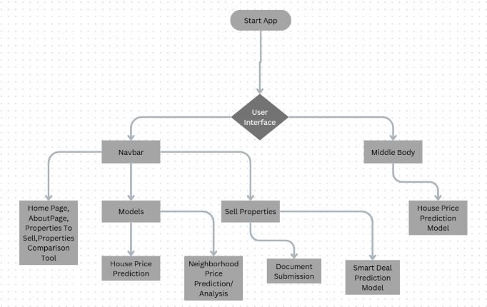

**Fig. 3:** *User Interaction Workflow with Integrated AI Models*.

1. **Start App:**

The application begins with a clear entry point where users access the platform.

1. **User Interface**:

* Acts as the central hub that guides the user to various features of the platform. This is likely the homepage or the main dashboard of the application.

1. **Navbar**:

Provides quick access to key sections such as:

* + **Home Page**: General information and overview.
  + **About Page**: Details about the platform and its features.
  + **Properties to Sell**: A section listing properties available for sale.
  + **Properties Comparison Tool**: Allows users to compare multiple properties based on specific criteria.

1. **Models**:

This section highlights AI-powered tools integrated into the platform:

* **House Price Prediction Model:** Predicts property prices based on market trends and data.
* **Neighbourhood Price Prediction Model:** Offers insights into price trends and property values in specific areas.

1. **Sell Properties:**

This feature focuses on property sellers:

* **Document Submission:** Ensures secure and verified listings through proper documentation.
* **Smart Deal Prediction Model**: Suggests price of the property price that is beneficial for both seller and customer and acts as the main feature of Apni Jagah.

1. **Middle Body**:

Represents the primary content area or core feature set of the application, directly leading to:

* + **House Price Prediction Model**: Calculates and predicts property values.

1. **Datasets:**

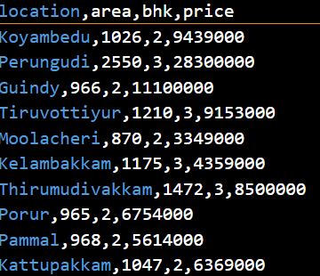

**Fig. 4:** *Dataset Features for Price Prediction*.

**How Does Apni Jagah Leverage Dataset Features for Accurate Real Estate Price Prediction?**

The dataset depicted in **Fig.4** is a valuable resource for building a real estate price prediction model, as it provides information on key factors that typically influence property prices. Let’s go through each feature in this dataset:

1. **Location:**  
   This column shows where each property is located, like Malad East, Ambernath West, or Borivali West. Location is one of the biggest factors in determining property prices because different areas have different demand levels, infrastructure, and amenities.
2. **Area:**  
   This column lists the size of each property in square feet. Generally, larger properties are more expensive, so the area is essential in predicting the price.
3. **BHK (Bedrooms, Hall, Kitchen)**:

This tells us the configuration or layout of the property, specifically the number of bedrooms it has. For example, a 1 BHK has one bedroom, while a 3 BHK has three. This is important because properties with more rooms are typically worth more and cater to different buyer preferences.

1. **Price**:

This is the actual price of the property and serves as the target variable for our prediction model. We’re using the other columns (like location, area, and BHK) to predict this value.

1. **For Users:**
   1. **For Seller:**

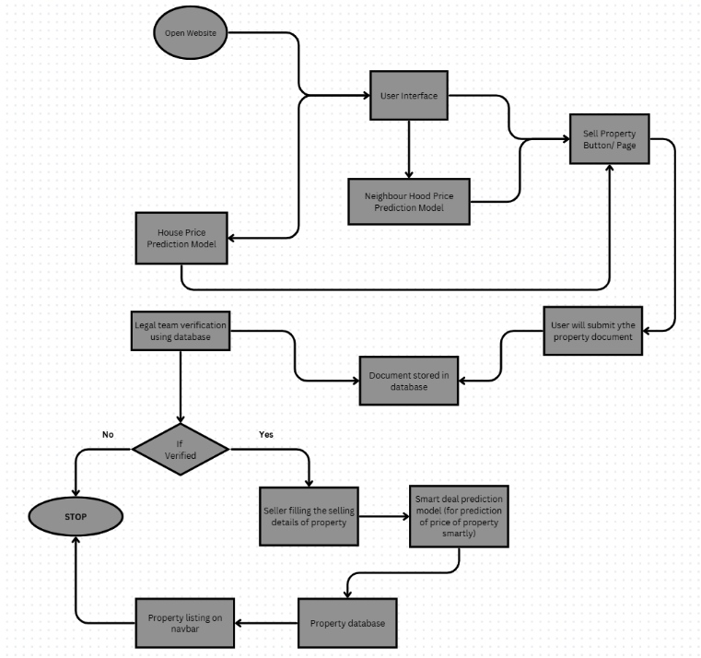

**Fig. 5:** *Seller Verification Workflow with AI-Driven Models*.

**How Does the Seller Interact with Apni Jagah's AI-Driven Platform?**

The flowchart of **Fig.5** outlines the process flow for a property-selling platform. Below is a detailed step-by-step explanation:

**1**. **Open Website**

* + The user begins by visiting the website.

**2**. **User Interface**

* + Users interact with the website's interface to navigate through the platform.

3. **Sell Property Button/Page**

* + Users looking to sell a property are directed to the Sell Property page via the interface.

**4**. **Neighbourhood Price Prediction Model**

* + The platform integrates a Neighbourhood Price Prediction Model to suggest a fair property price based on the local area.

**5.** **User Submission of Property Document**

* + Sellers upload required property documents to the platform for verification.

**6.** **Document Stored in Database**

* + The submitted documents are securely stored in a database for further processing.

**7.** **Legal Team Verification**

* + A Legal Team reviews the submitted documents to verify the authenticity and ownership of the property.
  + Decision Point:
    - If Verified (Yes): Proceed to the next steps for property listing.
    - If Not Verified (No): The process stops, and the user is notified of the failed verification.

**8.** **Seller Fills Property Details**

* + Once verified, the seller provides additional details about the property (e.g., description, photos).

**9.** **Smart Deal Prediction Model**

* + A Smart Deal Prediction Model analyzes the seller's provided price and predicts an optimized price to ensure a fair deal.

**10. Property Database**

* + The finalized details, including the predicted price, are stored in the Property Database.

**11.** **Property Listing on Navbar**

* + The verified property is listed on the website for buyers to view, making it available in the property listings section.

**Purpose of the Flowchart in Fig.5**

This workflow ensures:

* Property prices are fair (via prediction models).
* Sellers and properties are verified legally.
* The process is secure and transparent, benefiting both

buyers and sellers.

* 1. **For Buyer:**

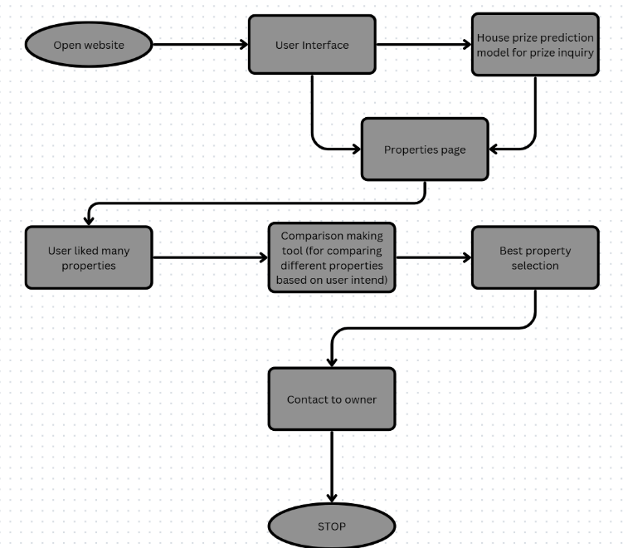 **Fig. 6:** *Buyer Navigation and Decision-Making Framework*.

**How Does the Buyer Interact with Apni Jagah's AI-Driven Platform?**

The flowchart depicted in **Fig.6** is an AI-powered real estate website that helps users find the best property based on their preferences, streamlining the search process.

**1. Open Website:**

* The user initiates the process by accessing the website.

**2. User Interface:**

* The user interacts with the website's interface, browsing through property listings and expressing their preferences.

**3. House Price Prediction Model:**

* The user can use model for enquiring house prices based on inputs like area, BHK, Location and etc. This can provide estimated values for properties.

**4. Properties Page:**

* The user navigates to a page displaying various properties, potentially filtered based on their preferences.

**5. User Liked Many Properties:**

* If the user expresses interest in multiple properties, an AI-powered comparison tool is activated.

**6. Comparison Making Tool:**

* This AI-powered tool analyzes the user's preferences and compares different properties based on their intent. It considers factors like price range, location, property type, and other relevant features highlighted by the user.

**7. Best Property Selection:**

* The AI model processes the comparison results and recommends the best property that aligns with the user's preferences and intent.

**8. Contact to Owner:**

* The user can then initiate contact with the owner or agent of the recommended property.

**STOP:**

1. **RESULTS & DISCUSSION**

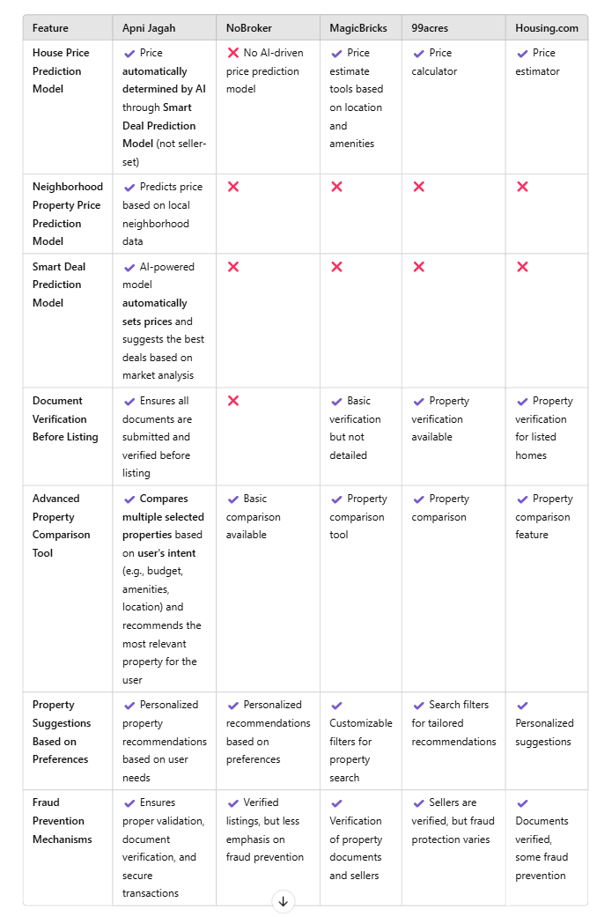 **Table 1: *Comparative Study of Apni Jagah vs. Traditional Systems***

**Why Apni Jagah Stands Out in the Real Estate Market?**

As observed from **Table 1 i.e. Comparative Study of Apni Jagah vs Traditional System**, Apni Jagah offers a clear edge over traditional real estate platforms with its advanced AI-powered features, such as the Smart Deal Prediction Model and AI-based Price Prediction, ensuring properties are priced accurately without relying on subjective seller inputs. This transparency removes the usual ambiguity surrounding property prices, providing more trust and clarity for both buyers and sellers.

1. **Key Strengths of Apni Jagah:**
2. **AI-based Price Predictions:**Unlike other platforms, Apni Jagah uses AI to predict property prices based on multiple market factors, making the pricing process more accurate and impartial.
3. **Smart Deal Prediction:** This feature helps buyers find the best deals based on comprehensive market analysis, making the platform more than just a listing service.
4. **Verified Documentation:** Apni Jagah ensures that all properties listed are backed by verified documentation, addressing a major concern in the real estate market—fraud prevention.
5. **Advanced Property Comparison:** The platform offers an advanced comparison tool that evaluates multiple properties based on user intent and preferences, making it easier for users to find the most relevant property.
6. **AI-Powered Personalization:** From price predictions to property suggestions, Apni Jagah’s AI-powered features ensure a highly personalized experience for users.

In contrast, other platforms like Housing.com, 99acres, and MagicBricks rely heavily on the seller to set prices and offer only basic price estimators. They lack the AI-driven tools that make property listings on Apni Jagah more accurate and trustworthy.

Apni Jagah is poised to revolutionize the real estate market by enhancing efficiency, accuracy, and transparency, addressing pain points that traditional platforms still face. With its data-driven insights, AI-powered features, and commitment to verified documentation, it is the future of property buying and selling.

1. **Key Findings of Apni Jagah:**
   1. **Smart Deal Prediction Model:**

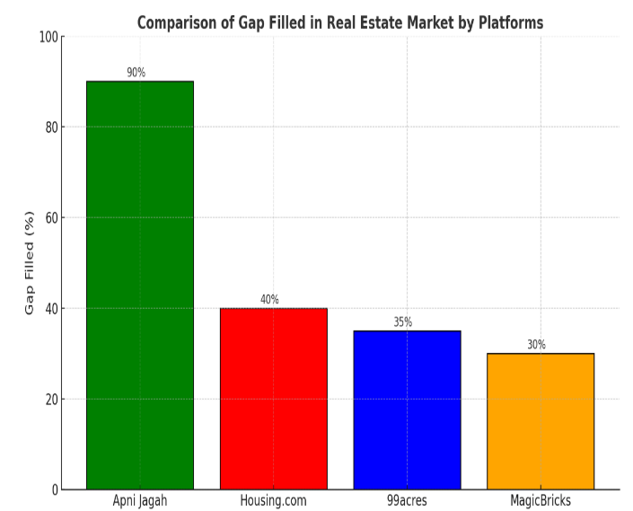

**Fig. 7:** *Bridging Real Estate Pricing Gaps with AI*.

As observed from above **Fig.7** the comparison of how Apni Jagah and other real estate platforms like Housing.com, 99acres, and MagicBricks address the gap in property price accuracy and fairness.

* Apni Jagah fills 90% of the gap, by its Smart Deal Prediction Model**( as mentioned in the methodology for Seller in Fig.5 i.e Sellers Interaction)** that benefits both buyers and sellers by balancing the seller's asking price with the actual market price.
* Traditional platforms lack such advanced AI-driven models, resulting in significantly lower percentages of gap-filled.
* The Smart Deal Prediction Model helps users by balancing seller and buyer expectations, ensuring fair pricing, reducing ambiguity, enhancing trust, and simplifying property negotiations for smarter, more transparent real estate transactions.
  1. **Neighborhood Price prediction Model:**

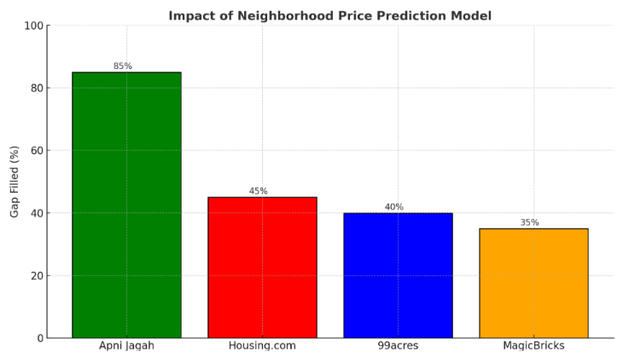

**Fig. 8:** *Neighborhood Price Prediction: Filling the Gaps*

Here's a bar graph in **Fig.8** comparing how Apni Jagah and other real estate platforms address the gap in neighborhood price prediction.

* Apni Jagah fills 85% of the gap using its Neighborhood Price Prediction Model, **(as mentioned in the methodology for Seller in Fig.5 i.e Sellers Interaction)** which evaluates property prices based on city, location, BHK, and square footage.
* Competing platforms like Housing.com, 99acres, and MagicBricks lack this advanced model, resulting in less comprehensive predictions.
* The Neighborhood Price Prediction Model benefits users by providing accurate local pricing, ensuring fair deals, aiding informed decisions, enhancing transparency, preventing fraud, and offering personalized insights for smarter real estate investments.
  1. **Properties Comparison Tool:**

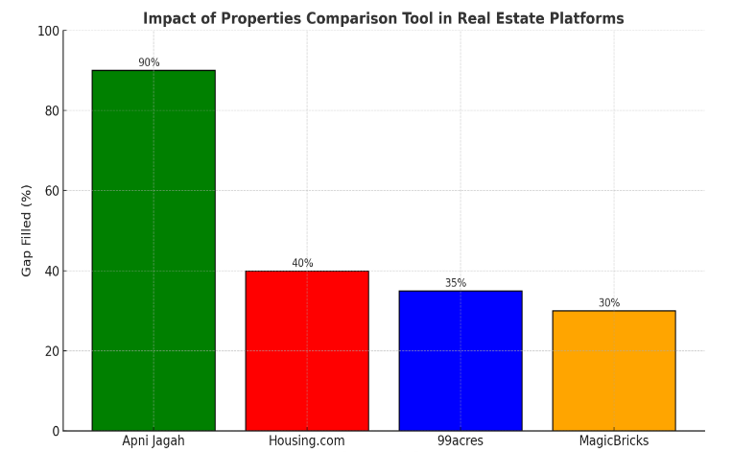 **Fig. 9:** *Advanced Property Comparison Tool Framework comparison with Traditional Real Estate System.*

The bar graph in **Fig.9** compares how Apni Jagah and other real estate platforms address the gap in property comparison tools.

* Apni Jagah fills 90% of the gap with its advanced Properties Comparison Tool, **( as mentioned in the methodology for Buyers in Fig.6 i.e Buyers Interaction)** thatallowing users to select and
* compare properties based on their specific intent and preferences, recommending the best option.
* Other platforms like Housing.com, 99acres, and MagicBricks lack such detailed comparison features, leaving a significant gap in personalized property matching.
* The Properties Comparison Tool allows users to effortlessly compare multiple properties based on personalized preferences, helping them make informed decisions, find the best match, and save time, all while ensuring transparency.

1. **Future Scope**

**1. Enhanced AI Features:**

* **Objective:** To implement advanced machine learning models that continuously improve price predictions and offer hyper-personalized property recommendations for buyers and sellers.
* **Impact:** This will ensure more accurate pricing, faster property matches, and tailored suggestions based on user behavior and preferences, creating a more intuitive and responsive platform.

**2. Map Integration Feature:**

* **Objective**: Incorporate interactive maps to verify property amenities based on specific cities, locations, and areas.
* **Impact:** Buyers can easily assess the proximity of key amenities such as schools, hospitals, parks, and public transportation, improving decision-making and enhancing user satisfaction.

3. **Augmented Reality (AR):**

* **Objective:** Introduce virtual property tours via AR to allow potential buyers to experience properties remotely in a highly immersive, interactive manner.
* **Impact:** This will offer a richer, more engaging experience for buyers, especially for those unable to visit properties in person, boosting engagement and conversion rates.

**4. Blockchain Integration:**

* **Objective:** Integrate blockchain technology to ensure secure, transparent transactions and property documentation.
* **Impact:** Blockchain will enhance trust in the platform, protect against fraud, and provide an immutable record of all transactions, making property transfers faster and more secure.

**5. Localized Services:**

* **Objective:** Tailor property listings and price evaluations to specific regions and cities, offering more relevant suggestions based on location-specific market trends.
* **Impact:** Users will get more accurate and relevant recommendations, improving their overall search experience and increasing the likelihood of finding the right property.

**6. Advanced Tools for Users:**

* **Objective:** Add advanced tools such as rental yield calculators, investment growth predictions, and loan

eligibility assessments to attract property investors and renters.

* **Impact:** This will help investors make more informed decisions about potential properties, providing them with key financial insights to maximize ROI.

**7. All-in-One Ecosystem:**

* **Objective:** Partner with banks, legal experts, and construction companies to provide a comprehensive solution for property buyers and sellers.
* **Impact:** Users can seamlessly handle all aspects of the property transaction process—from financing to legal documentation—making Apni Jagah a one-stop solution.

**8. International Expansion:**

* **Objective:** Target Indian expatriates and expand the platform's services to global markets.
* **Impact:** By catering to Indian expats and international buyers, Apni Jagah can broaden its user base and increase its global reach, creating new opportunities for property transactions.

**9. Sustainability Features:**

* **Objective:** Highlight eco-friendly properties and provide tools to assess the environmental impact of properties.
* **Impact:** As sustainability becomes a key consideration for buyers, this feature will cater to environmentally conscious consumers, promoting green initiatives in real estate.

**10. Data-Driven Insights:**

* **Objective:** Leverage big data to analyze market trends and buyer behavior, offering actionable insights to users.
* **Impact:** This will help users understand the market better and make more informed decisions, while also enabling Apni Jagah to adapt to shifting trends and provide more relevant property recommendations.

**11. Improved Accessibility:**

* **Objective:** Develop mobile-first features for rural users and integrate regional languages for greater inclusivity.
* **Impact**: This will make Apni Jagah more accessible to a wider audience, ensuring that users from diverse geographical locations and linguistic backgrounds can easily use the platform, increasing its adoption rate.

**12. Social Media Integration for Advertising:**

* **Objective:** Integrate social media platforms into the Apni Jagah ecosystem, allowing agents and landowners to advertise their properties directly on platforms like Facebook, Instagram, Twitter, and LinkedIn.
* **Impact:** This feature will expand the marketing reach of property listings, driving more visibility and engagement. It will also allow agents and sellers to target specific demographics based on location, interests, and other factors, leading to faster sales and more relevant leads.

1. **Hypothesis**

**Why to Choose Apni Jagah: AI-Driven Solutions for Optimizing Real Estate Systems?**

**1. Resolving a Price Dispute**

**Scenario:**

* Ravi wants to sell his 2 BHK apartment in Noida. He lists it at ₹60 lakhs on *Apni Jagah*. However, a buyer, Priya, claims the price is inflated compared to similar properties in the area.

**Solution:**

* **Neighborhood Price Prediction Model:** *Apni Jagah* evaluates Ravi's property using local market data and comparable property trends. It predicts a fair market value of ₹57 lakhs.
* **Smart Deal Prediction Model:** The system recommends a negotiation midpoint at ₹58.5 lakhs, balancing Ravi’s expectations and Priya’s budget.
* **Outcome:** Ravi and Priya agree on ₹58.5 lakhs, facilitated by the platform’s AI-driven transparency, saving both parties time and avoiding potential disputes.

**2. Preventing Fraudulent Listings**

**Scenario:**

* Sneha, a buyer, finds a property listing on *Apni Jagah* for ₹1 crore. She expresses interest, but she’s worried about the seller's authenticity.

**Solution:**

* **Document Verification System:** The seller is required to upload property ownership documents, which are validated by *Apni Jagah’s* AI-powered legal verification team. The system detects a mismatch between the uploaded documents and government records, flagging the listing as fraudulent.
* **Outcome:** The fraudulent listing is removed, and Sneha avoids a potentially disastrous transaction.

**3. Assisting with Underpriced Property**

**Scenario:**

* Raj, a seller, lists his commercial space in Pune for ₹50 lakhs. A competitor informs him it’s undervalued compared to market rates.

**Solution:**

* **Smart Deal Prediction Model:** The AI evaluates the area’s market trends, demand, and recent transactions, identifying the property’s actual value as ₹60 lakhs.
* **Price Adjustment Suggestion:** The platform recommends Raj adjust the listing price to ₹60 lakhs

to reflect its true worth.

* **Outcome:** Raj updates the price, and within a week, a buyer agrees to purchase it at the new rate. The platform ensures Raj does not lose out on profit.

**4. Secure Property Locking**

**Scenario:**

* Amit and Preeti finalize a deal on *Apni Jagah* for a property worth ₹85 lakhs. Preeti pays a token amount of ₹2 lakhs but worries about the deal falling through.

**Solution:**

* **Property Locking Mechanism:** After receiving the token payment, *Apni Jagah* locks the property listing, preventing other buyers from accessing it.
* **Transaction Tracking:** Preeti and Amit both receive a secure digital agreement verifying the transaction, with further payments tracked via the platform.
* **Outcome:** Both parties feel confident in the transaction’s security and transparency.

**5. Reducing Buyer Confusion in Property Comparison**

**Scenario:**

* Arjun is torn between three properties in Bengaluru, each offering different advantages. He struggles to make a decision.

**Solution:**

* **Property Comparison Tool:** Arjun inputs his preferences (e.g., budget, proximity to schools, and public transport). The platform evaluates all three properties using AI and recommends the one with the best match based on Arjun’s priorities.
* **Outcome:** Arjun selects a property within his budget, meeting 95% of his criteria, and avoids over-analysis or decision paralysis.

**6. Streamlining Legal Disputes**

* **Scenario:**

Pooja, a buyer, discovers after a purchase that the property she bought has unresolved legal issues with encroachments.

**Solution:**

* **Legal Document Verification:** *Apni Jagah* ensures all properties undergo a thorough legal review before listing. This includes cross-verifying ownership, encumbrances, and government compliance.
* **Outcome:** Pooja purchases a legally verified property, avoiding legal complications. This builds trust and ensures compliance with real estate regulations.

**7. Assisting First-Time Buyers**

**Scenario:**

* Sunita, a first-time homebuyer, feels overwhelmed by the process of finding and negotiating for a home in Mumbai.

**Solution:**

* **AI-Powered Guidance:** *Apni Jagah* uses her preferences (e.g., budget, location, and property type) to recommend properties, providing detailed pricing predictions and transparency.
* **Personalized Recommendations:** The platform guides her step-by-step, from shortlisting properties to making an offer and signing agreements.
* **Outcome:** Sunita buys her first home confidently, thanks to the platform’s end-to-end support.

1. **Machine Learning Algorithm Evaluation:**

Referring to **Table 2**, the machine learning algorithms compared for performance evaluation include Logistic Regression, Decision Tree, and Random Forest.

|  |  |  |
| --- | --- | --- |
| Model | MAE | R2 (Score) |
| Logistic Regression | 4,833,250.00 | 0.15 |
| Decision Tree | 1,848,901.61 | 0.78 |
| Random Forest | 1,692,424.65 | 0.85 |

**Table 2:** Performance Metrics of Machine Learning Algorithms

Random Forest emerges as the top-performing model, achieving the lowest Mean Absolute Error (MAE) of 1,692,424.65 and the highest R-squared (R²) score of 0.85, indicating superior accuracy and reliability. While Decision Tree follows with a respectable R² score of 0.78, Logistic Regression lags with an R² score of only 0.15. Consequently, Random Forest is the most suitable choice for achieving high precision, particularly with extensive datasets.

**Why does the Random Forest outperform?**

Random Forest outperformed due to its ensemble learning, combining multiple decision trees to reduce overfitting and improve accuracy. It handles non-linearity, automatically selects relevant features, and reduces variance. Its out-of-bag error estimation enhances generalization, making it more robust than Decision Trees or Logistic Regression.

1. **CONCLUSION**

Apni Jagah establishes itself as a leading platform in the real estate industry by addressing persistent challenges such as price ambiguity, lack of transparency, and inefficiencies through advanced AI-powered solutions. Unlike [1], which emphasizes verified listings, or [2] and [3], which focus on basic search filters, Apni Jagah leverages predictive analytics,

fraud prevention mechanisms, and smart deal suggestions to create a transparent, data-driven ecosystem. Platforms like [4] eliminate intermediaries but lack Apni Jagah’s price prediction and robust document verification features. While [6], [8], and similar platforms provide curated listings, Apni Jagah stands out with its hyper-personalized recommendations and advanced comparison tools that simplify decision-making for buyers and sellers. By integrating future-focused technologies such as blockchain for secure transactions and augmented reality for immersive property tours, Apni Jagah surpasses traditional platforms like [9] and [13], ensuring a secure, efficient, and user-centric property transaction experience.

1. **ACKNOWLEDGEMENT**

We would like to express our sincere gratitude to all those who have contributed to the completion of this research paper.

First and foremost, we are deeply indebted to our advisor, Mrs. Vandna Tomar, whose expertise, understanding, and patience added considerably to our graduate experience. We appreciate her vast knowledge and skill in many areas and her assistance in writing reports and code.

Special thanks are due to IMS Engineering College Ghaziabad and AKTU University for providing the necessary resources and environment for conducting our research.

Lastly, We wish to thank all the participants of our study, without whom this research would not hav been possible.

Thank you all for your invaluable contributions.

1. **REFERENCES**
2. Chauhan, Rahul, Tushar Sharma, Ruchira Rawat, Rudresh Pillai, and Kanegonda Ravi Chythanya. "A comparative Analyis of House Price Prediction Algorithms." In *2024 IEEE 9th International Conference for Convergence in Technology (I2CT)*, pp. 1-6. IEEE, 2024.
3. Datrange, Kushal Vilas, Rohit R. Salgude, and U. S. Agrawal. "Challenges and opportunities in the Real Estate Act, 2016, India: A focus on judicial appellate and redevelopment projects." *International Journal of Construction Management* 24, no. 16 (2024): 1751-1759.
4. Dutta, Arnab, Richard K. Green, Venkatesh Panchapagesan, and Madalasa Venkataraman. "Are Move-In Ready Homes More Expensive? Are Move-In Ready Homes More Expensive?." *The Journal of Real Estate Finance and Economics* (2024): 1-39.
5. Kansal, Mrignainy, Pancham Singh, Ujjwal Agarwal, Kartikay Singhal, Keshav Arora, and Manish Dixit. "Enhancing Real Estate Price Prediction in Smart Cities: A Comparative Analysis of Machine Learning Techniques." In *International Conference on Advances in Distributed Computing and Machine Learning*, pp. 71-84. Singapore: Springer Nature Singapore, 2024.
6. Kaur, Taran, Sanjeev Bansal, and Priya Solomon. "The changing real estate investment dynamics in Indian holy cities: effect of spirituality on property buying
7. behavior." *Journal of Cultural Heritage Management and Sustainable Development* 14, no. 4 (2024): 730-749.
8. Pandey, Anurag Kumar, Anil Goyal, and Nikhil Sikka. "RE-RFME: Real-Estate RFME Model for customer segmentation." *arXiv preprint arXiv:2404.17177* (2024).
9. Kishore, Kaushal. "Opportunities and challenges ahead of start-ups in emerging markets in the era of sharing economy and globalisation." *International Journal of Business and Globalisation* 38, no. 2 (2024): 207-217.
10. Jain, Prachi. "E RETAILING IN INDIA." *Management and Information Technology* (2024): 27.
11. KHAN, MUHAMMAD KASHIF, and MARTINA KIRCHBERGER. "Housing price prediction using numeric and textual data in Karachi." (2024).
12. Eide, Ludvik, and Sebastian Wilhelmsen. "The Emerging Economy India: The effect of macroeconomic factors on real estate prices in the Indian Property market." Master's thesis, Handelshøyskolen BI, 2024.
13. Agnihotri, Vivek, and Saikat Kumar Paul. "Housing market shifts favouring transit-oriented development in emerging economies: the link between metro rails and housing price dynamics in Delhi." *International Journal of Housing Markets and Analysis* 17, no. 1 (2024): 8-31.
14. Gautam, Abhishek, Ashok Kumar, Sahendra Ram, Krzysztof Skrzypkowski, Krzysztof Zagórski, Anna Zagórska, Krzysztof Migda, and Maciej Madziarz. "Strata Control by Roof Blasting for Bord and Pillar Mining Method for Mechanised Depillaring Panel." (2024).
15. Singh, Shefali, Manoj Joshi, Meenakshi Gandhi, and Komal Malik. "Sustainability and resilient strategies by entrepreneurial firms in a VUCA world." *World Review of Entrepreneurship, Management and Sustainable Development* 20, no. 3 (2024): 291-308.
16. EGUNLETI, IO, VO IGE, CO ASAOLU, and IO BIBILARI. "MODELLING THE EFFECT OF SOCIAL MEDIA ON REAL ESTATE MARKETING IN AKURE, NIGERIA." *Ethiopian Journal of Environmental Studies & Management* 17, no. 4 (2024): 499-509.
17. Chotangada, Gautham Somana. "Examination of Airbnb Demand and Supply in India." PhD diss., Massachusetts Institute of Technology,